Computer Vision hw_8

By R01922124 許彥彬

1. Intro of this homework:   
   In this homework we first generate Gaussian noise image and salt-and-pepper noise image on lena.bmp. Then we use box filter, median filter, opening followed by closing, and closing followed by opening to clean the noise.  
   These are the functions that are going to use in this homework.  
   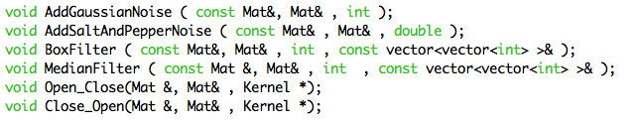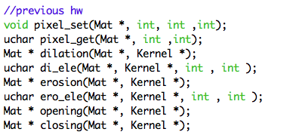
2. Generate additive white Gaussian noise
   1. Formula:  
       
   2. Code:  
      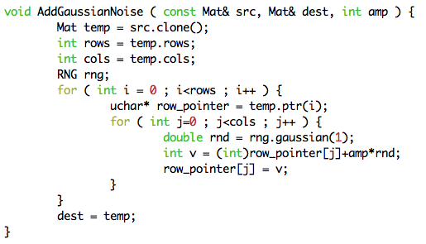
3. Generate salt-and-pepper noise
   1. Formula:  
       
   2. Code:  
      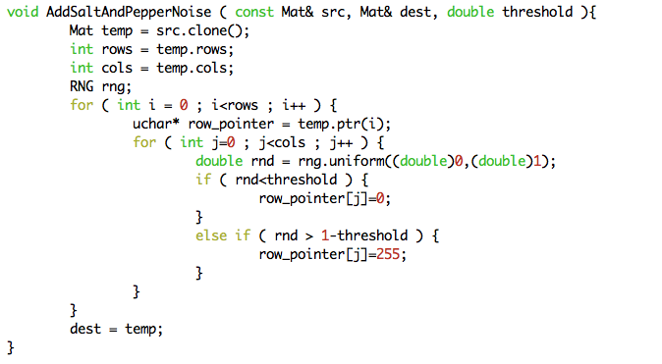
4. Box filter
   1. Idea: Average the gray scale values in a given mask and set the average value to target image.
   2. Code:  
      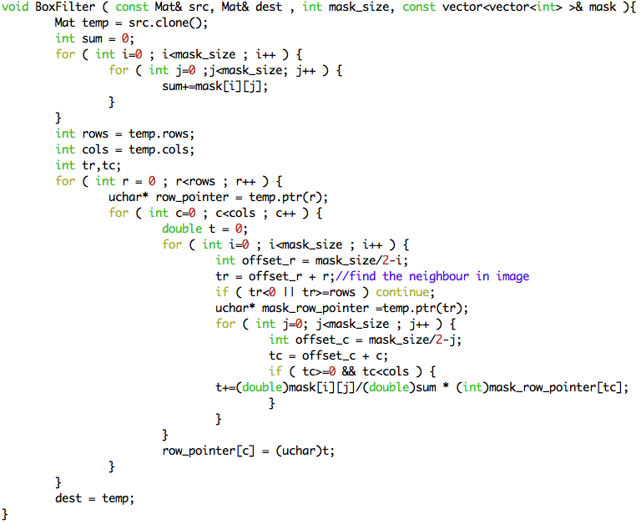
5. Median Filter
   1. Idea: Set the target image using the median value of a given mask.
   2. Code:  
      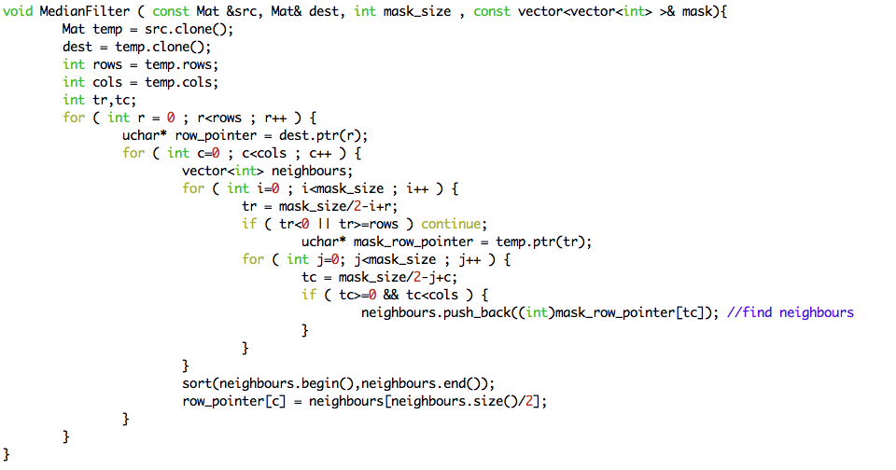
6. Opening followed by closing and closing followed by opening
   1. Idea: These two functions were discussed in homework 5. The kernel I used here is kernel octagon.
   2. Code:  
      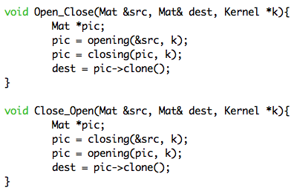
7. Results:
8. Noise Images:

|  |  |
| --- | --- |
|  |  |
| Gaussian noise with amplitude 10 | Gaussian noise with amplitude 30 |
|  |  |
| Salt-and-pepper noise with probability 0.05 | Salt-and-pepper noise with probability 0.1 |

1. Filter on Gaussian noise image with amplitude 10:

|  |  |
| --- | --- |
|  |  |
| 3by3 box filter on Gaussian noise with amplitude 10 | 5by5 box filter on Gaussian noise with amplitude 10 |
|  |  |
| 3by3 median filter on Gaussian noise with amplitude 10 | 5by5 median filter on Gaussian noise with amplitude 10 |
|  |  |
| Opening followed by closing on Gaussian noise with amplitude 10 | Closing followed by opening on Gaussian noise with amplitude 10 |

1. Filter on Gaussian noise image with amplitude 30:

|  |  |
| --- | --- |
|  |  |
| 3by3 box filter on Gaussian noise with amplitude 30 | 5by5 box filter on Gaussian noise with amplitude 30 |
|  |  |
| 3by3 median filter on Gaussian noise with amplitude 30 | 5by5 median filter on Gaussian noise with amplitude 30 |
|  |  |
| Opening followed by closing on Gaussian noise with amplitude 30 | Closing followed by opening on Gaussian noise with amplitude 30 |

1. Filter on salt-and-pepper noise image with probability 0.05:

|  |  |
| --- | --- |
|  |  |
| 3by3 box filter on salt-pepper noise with probability 0.05 | 5by5 box filter on salt-pepper noise with probability 0.05 |
|  |  |
| 3by3 median filter on salt-pepper noise with probability 0.05 | 5by5 median filter on salt-pepper noise with probability 0.05 |
|  |  |
| Opening followed by closing on salt-pepper noise with probability 0.05 | Closing followed by opening on salt-pepper noise with probability 0.05 |

1. Filter on salt-and-pepper noise image with probability 0.1：

|  |  |
| --- | --- |
|  |  |
| 3by3 box filter on salt-pepper noise with probability 0.1 | 5by5 box filter on salt-pepper noise with probability 0.1 |
|  |  |
| 3by3 median filter on salt-pepper noise with probability 0.1 | 5by5 median filter on salt-pepper noise with probability 0.1 |
|  |  |
| Opening followed by closing on salt-pepper noise with probability 0.1 | Closing followed by opening on salt-pepper noise with probability 0.1 |

1. Appendix
   1. build_all.sh  
      “sh build_all.sh” will automatically compile the code in terminal.
   2. R01922124_HW8.cpp  
      source code
   3. lena.bmp  
      original lena image
   4. Many result images
   5. R01922124_HW8.pdf  
      report